Code of Conduct – Gloucestershire Cricket Foundation STAFF

Introduction
The Gloucestershire Cricket Foundation (GCF) takes its role as a provider of cricket for children and young people very seriously. Their wellbeing is paramount in all decisions taken by us. All children and young people we encounter have the same protection regardless of age, disability, gender, race, religious belief, or sexual orientation. The GCF also commits to safeguarding adults at risk.

We act in accordance with legislation, statutory guidance and the ECB Safe Hands Policy and work collaboratively with the ECB in relation to concerns around the safeguarding of children, young people, and adults at risk.

To whom does this Code of Conduct Apply?
This Code of Conduct applies to all staff, as safeguarding is everyone’s responsibility. It therefore applies to and is required to be signed by employees, consultants, contractors, casual and agency staff (collectively referred to as staff in this Code of Conduct). It does not apply to volunteers, who should adhere to the Volunteer Code of Conduct.

Staff Expectations
It is our expectation that all our staff will always act in the best interests of children and young people under the age of 18 and in accordance with the ECB Safe Hands Policy. The welfare of children and young people must always be paramount. We also expect our staff to act in the best interests of adults at risk in cricket.

This includes an expectation that staff will:
- Undertake safeguarding education or training as required by the Gloucestershire County Cricket Club (GCCC) /GCF.
- Read and comply with ECB Safe Hands Policy
- Be appropriately vetted if required to do so as specified in Safe Hands
- Act in an appropriate way always when in contact with children and young people and adults at risk, whether face-to-face, via social media, phone or by any other electronic communications.
- Recognise the importance of confidentiality when working with children, young people, their families, and their data.
- Promptly report any concerns about safeguarding or the protection of children or young people in cricket to the County Safeguarding Officer or ECB Safeguarding Team.
- Be familiar with and use the whistle blowing policy if you suspect or believe that safeguarding concerns have not been appropriately addressed by the GCCC/GCF.
- Accept that, by taking this role, you may be deemed to be in a relationship of trust with under-18 participants that you are in contact with.
- Act with integrity always.
- Seek advice from the County Safeguarding Officer or ECB Safeguarding Team if required.

Further information and support
Further safeguarding information is available in Safe Hands.

If you have any queries or concerns regarding the Code of Conduct or
safeguarding generally, please speak to your County Safeguarding Officer in the first instance.

Please sign and return this Code of Conduct to acknowledge you have read, understood, and agree to comply with the document. You should also keep a copy for your records.

Name: Steve Silk
Signed: 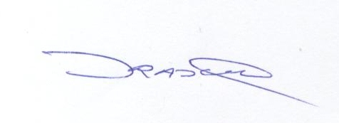

Date: 01/11/2023

Policy Review Date- 30th September 2024

