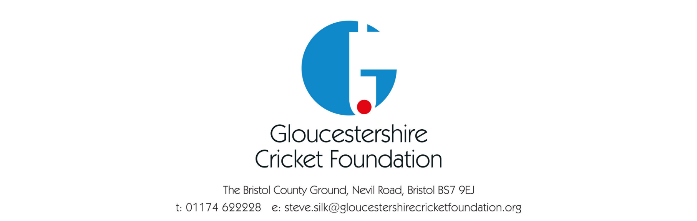

ECB Safeguarding Procedures - Thresholds

To manage expectations across the Cricket network, and individuals involved in investigations (either as a person under investigation or a witness) The ECB Safeguarding Team has clear thresholds of cases they will manage.

- Any referral relating to an allegation which meets the threshold of a statutory agency investigation.
- Any referral where the person under investigation is employed within a position of Trust
- Any referral where the person under investigation has a designated safeguarding responsibility within Cricket.
- Any referral relating to sexual misconduct (to include conduct over internet enabled devices) within the context of Cricket.
- Any referral relating to a physical assault on a child within the context of Cricket.
- Any referral about a managed participant in Cricket.
- Any referral relating to a Registered Sex Offender.
- Any referral involving an ECB employee
- Any referral relating to three or more incidents* of poor practice/low level concern.
- Any other referral where the ECB Safeguarding Team considers there is significant reputational risk to the ECB (high profile individual).

* Incidents must be previously reported and recorded to Club, County or ECB Safeguarding Team.

Upon receipt of an appropriate referral, the ECB Safeguarding Team will advise if the case meets the threshold criteria.

If the referral does not meet the threshold this will be clearly communicated.

For concerns not meeting the ECB threshold, any action required will be managed by the CCB, including complaints of poor practice. Support and advice are available from your ECB County Safeguarding Advisor.

We would advise that counties use the Managing Safeguarding Information guidance in relation to any referrals.

Policy Review Date: 30th September 2024

