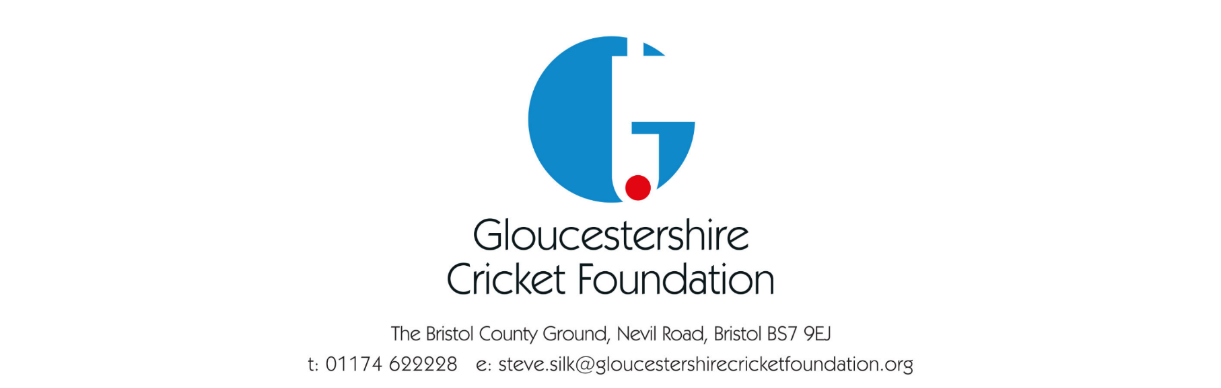

Gloucestershire Cricket Foundation- Anti Bullying Policy

Anti-Bullying Policy- Statement of intent
We are committed to providing a caring, friendly, and safe environment for all our children, so they can train, learn, and play, in a relaxed and secure atmosphere. Bullying of any kind is unacceptable.
If bullying does occur, all children should be able to tell, and know, incidents will be dealt with promptly and effectively. This means anyone who knows bullying is happening is expected to tell someone who can do something about it.
What is bullying?
Bullying is the use of aggression with the intention of hurting another person. Bullying results in pain and distress to the victim. Bullying can take many forms:
- Emotional: being unfriendly, excluding, tormenting (for example: hiding kit, or making threatening gestures)
- Physical: pushing, kicking, hitting, punching or any use of violence
- Racist: racial taunts, graffiti and/or gestures
- Sexual: unwanted physical contact or sexually abusive comments
- Homophobic: because of, or focusing on, the issue of sexuality
- Verbal: name-calling, sarcasm, spreading rumours and teasing
- Cyber: bullying behaviour online or via electronic communication (email and text, social media etc) Misuse of associated technology, such as camera and video facilities
Why is it important to respond to bullying?
Bullying hurts. No one should be a victim of bullying. Everyone has the right to be treated with respect. Children who are bullying also need to learn different ways of behaving.
Cricket clubs and Boards have a responsibility to respond promptly, and effectively, to issues of bullying. Please report any bullying complaints to your County Safeguarding Officer.
Objectives of this policy
- All adults and children should understand what bullying is
- All officials, coaching and non-coaching staff should know what the club policy is on bullying, and follow it when bullying is reported
- All children and parents should know what the club policy is on bullying, and what they should do if bullying arises
- Bullying will not be tolerated
For more information, please contact safeguarding@gloucestershirecricketfoundation.org .

Policy Completion Date- January 2022
Policy Review Date- 30th September 2023

