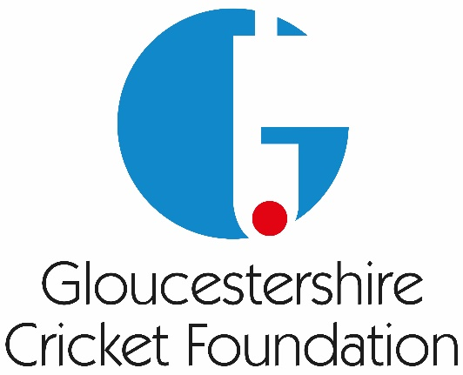

Raffle/Prize List
 | Prize | Courtesy of
1 | GCCC Signed One Day Shirt  4 tickets to Vitality Blast at Bristol  4 tickets to Metro Bank One Day Cup  4 tickets to Rothesay County  Championship @ Cheltenham  4 tickets to Rothesay County Championship @ Bristol | 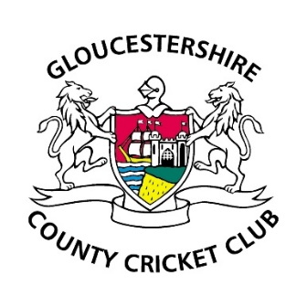
2
3
4
5
6 | Cheltenham Races  2 Club Enclosure Tickets during the 2025/2026 season | 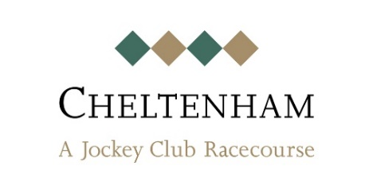
7 | Bath Netball  4 Tickets during the 2027 season | 
8 | Dinner for 4 at The Squire Inn  (The Sodbury Steak House) in Chipping Sodbury | 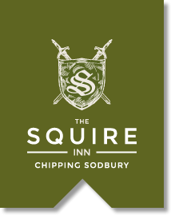
9 | Cheltenham Town FC  2 tickets to home league game 2026/2027 season | 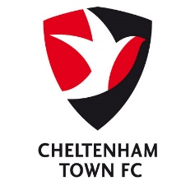
10 | Bristol Sport Foundation  Bristol City FC  2 tickets to a 2026/2027 game | 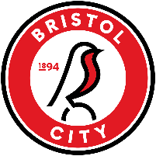
11 | Bristol Sport Foundation  Bristol Bears RFC  2 tickets to a 2026/2027 game | 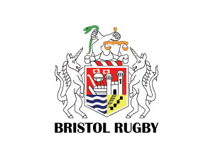
12 | Porsche Drivers selection  Golf Balls, Cap and Mug | 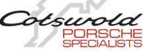
13 | Titleist Pro V1 Balls  Marker, Tee set | 
14 | JBL Tune Beam 2 Wireless Noise Cancelling Earbuds (Black) | 
15 | Batting Lane Gift Voucher  1 x 2 hour batting lane session | 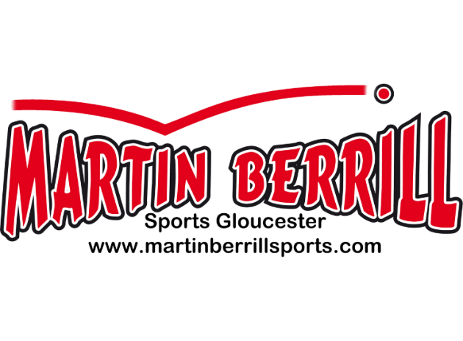
16 | Batting Lane Gift Voucher  1 x 2 hour batting lane session

