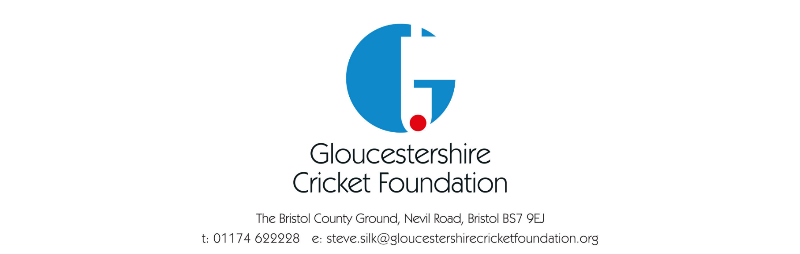

Gloucestershire Cricket Foundation – Safeguarding Policy Statement

Gloucestershire Cricket Foundation is committed to ensuring all children (i.e all persons under the age of 18 years) and adults at risk participating in cricket, have a safe and positive experience.

Please see the following:

- Putting things in place.
- Having the right people in place.
- What to do if you have a concern.
- Cricket specific guidance.

1) Putting things in place.

We recognise all children participating in cricket (regardless of age, gender, race, religion, sexual orientation, ability, or disability) have the right to have fun and be protected from harm, in a safe environment.

We ensure individuals working within cricket at, or for, our club provide a welcoming, safe, and fun experience for children.

We provide an environment where the views of children, parents and volunteers are sought and are welcome on a range of issues. This will help us create an environment where people can voice any concerns (about suspected child abuse/neglect and/or about poor practice) to the Club Safeguarding Officer.

We adopt and implement the England and Wales Cricket Board (ECB) “Safe Hands – Cricket’s Policy for Safeguarding Children.”

We ensure all individuals working within cricket at, or for, the club are recruited and appointed in accordance with ECB guidelines and relevant legislation.

- Having the Right People in Place.

Appointing a County Safeguarding Officer and ensuring they attend training as required by the ECB. Our County Safeguarding Officer’s details are:

Name – Ellen Mutch
Email address – safeguarding@gloucestershirecricketfoundation.org
Phone number – 07852 815430

County Safeguarding Officer’s role.

  - Point of contact for clubs, leagues, parents, children, and volunteers/staff within the county.
  - As a source of procedural advice for the county’s clubs and leagues and their members.
  - The main point of contact within the county for Club Safeguarding/Welfare Officers and the ECB Safeguarding Team.
  - The main point of contact within the county for relevant external agencies, in connection with child safeguarding. Ensuring correct and comprehensive reporting procedures exist for raising and managing child safeguarding concerns.
- What to do if you have a concern.

We ensure all suspicions, concerns and allegations are taken seriously and dealt with swiftly and appropriately.

We ensure access to confidential information relating to child safeguarding matters, is restricted to those who need to know, to safeguard children.

This would include the Club Safeguarding Officer and appropriate external authorities, such as the Local Authority Designated Officer (LADO), as specified within ECB child safeguarding procedures.

- Cricket Specific Advice

We ensure all individuals working within cricket at, or for, the club are provided with support, through education and training, so they are aware of, and can adhere to, good practice and Code of Conduct guidelines as defined by the ECB and the club.

We ensure all people who work in cricket at, or for, our club (such as staff, officials, volunteers, team managers, coaches and so on) understand how the “Safe Hands Policy” applies to them.

For more information on the ECB Safeguarding Safehands Policy please click here: ECB.co.uk - About

Date Completed – 04/02/2021
Completed By – Stephen Silk (CEO)

Policy Completion Date- January 2022
Policy Review Date- 30th September 2023

