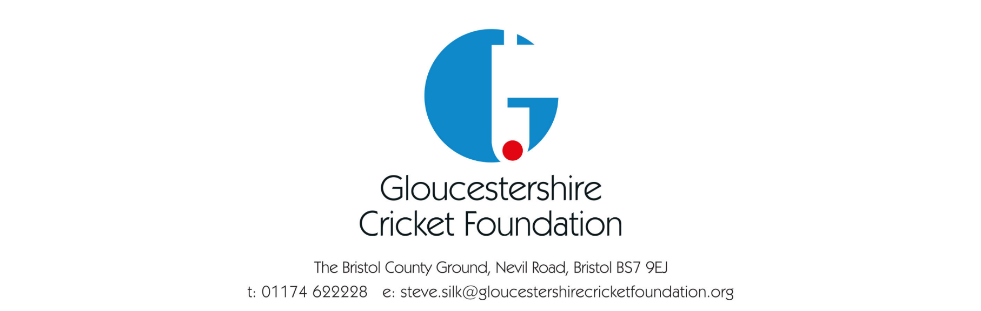

Zero Tolerance Policy- Performance Cricket

Gloucestershire Cricket has had an excellent tradition of behaviour both on the field and off from parents and players for the past number of years. To uphold this tradition, Gloucestershire Cricket has agreed to adopt a ‘Zero Tolerance’ policy towards any infringement of the Parents or Players Code of Conduct.

All Players and Parents have signed up to the Gloucestershire Cricket Codes of Conduct which outlines the standards of behaviour required for Representing Gloucestershire Cricket. Any guests of players are automatically agreeing to the code of conduct for Parents and Guests.

If a Team Manager or Team Coach feel that a player or parent has broken their code, then they will have every right to invoke the Zero Tolerance policy. They will do this by phoning their ‘line manager’.

The ‘Line Manager’ will have the power to contact the parent or player on the date of the accusation by the Team Manager or Team Coach. Following the conversation with the accused, the ‘Line Manager’ will decide too either:
- Find not guilty.
- Offer a verbal warning to the accused of future conduct.
- Suspend the accused with immediate effect and start the disciplinary process.
If Point A is decided, then the ‘Line Manager’ will speak to the Team Manager and Team Coach and explain the decision and possibly discuss the Codes and offer guidance on them.

If Point B is decided, then the ‘Line Manager’ will record the conversations and keep a copy of the record for a period of 12 months.

If Point C is decided, then the ‘Line Manager’ will notify the relevant people and begin the process outlined in “Gloucestershire Cricket – Disciplinary Panel, Terms of Reference”.

In any case involving a player under the age of 18, the ‘Line Manager’ will contact the County Safeguarding Officer (CSO). The CSO will then be involved in the case throughout the process and has the power to progress the incident to higher authorities if deemed necessary.

Policy Completion Date- January 2022
Policy Review Date- 30th September 2023

